Comp6215 – Kirk Remin - 10004981

Assignment 1

Semester 2

3/08/20

## Design Concept

Students and other people struggle to start new careers as they have no experience in the field other than their studies or interest. But there is always a job in any field that requires very little or no understanding of the field your entering that give you experience.

This would be like the uber of any industry.

What if you could sign up as a freelance contractor and list your experience and skill sets and apply not for full time positions but for an individual job that someone in their industry just doesn’t want to get done.

Employers could sign up to this service and pay very little for jobs to get done that they would rather not give their regular staff as they could be focused on more important issues.

This is not limited to the tech community but also works for laboring positions or even hospitality. You could list commission based tasks. Like be a waiter for a single night, move some tiles as a builder, help comb through and organize a stack of paperwork. Test a single application for a day.

* Bullet points on why its good

Add in the mind map from home and design idea documents

## Design Structure

Explanantion of what the diagram is and such…

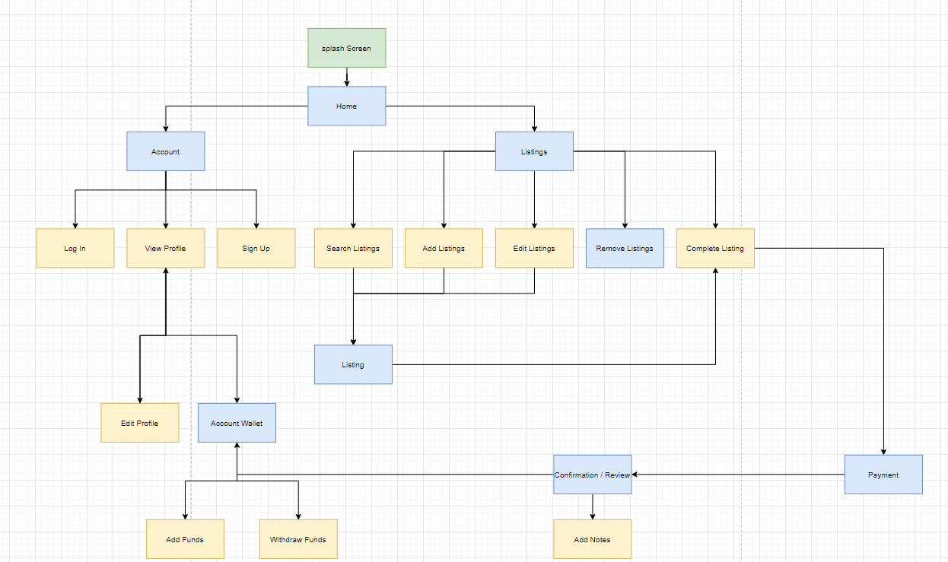

## Design Interaction

Storyboards / wireframes low-fidelity

Wireframes that can be broken down further into functions such as:

a set of wireframes on the menu. A set of

a set for the ceration, update and delete of a listing

the application for a listing and returning to a listing

the completetion of a listing

the profile creation and withdrawel of funds.

So on.

## Design Visuals



### Logo:

<https://coolors.co/85c806-c9a174-ffffff-3b1500-2f2f2f>

more words

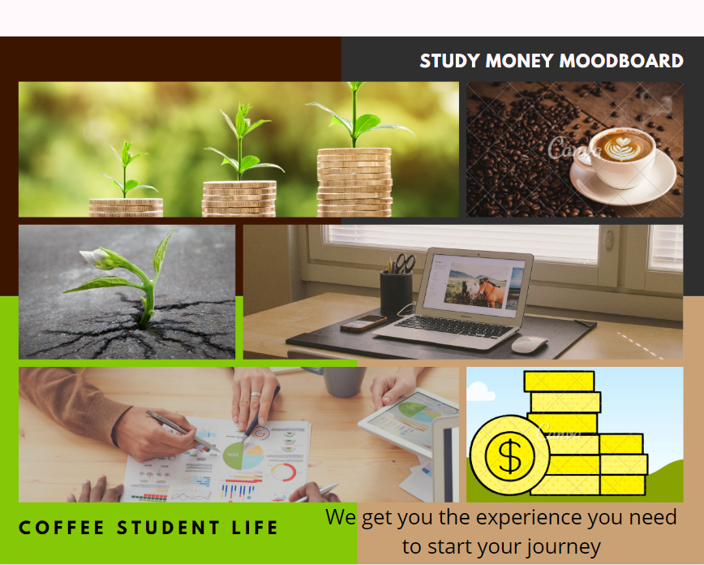

## Design Prototype